**The Future of University Decision Making with Machine Learning**

Team Leader : Viji k

Member 1 : Kavusalya s

Member 2 : Bhuvaneswari v

member 3 : Gowsalya v

***Table of contents:***

Introduction Machine Learning :

Overview of University admission :

Problem definition :

Result :

Advantage & disadvantage :

Application :

Conclision :

Future scope :

Appendix :

***INTRODUCTION:***

*University admission or college admission is the process through which students enter*

*tertiary education at universities and colleges. Systems vary widely from country to country, and sometimes from institution to institution.*

In many countries, prospective university students apply for admission during their last year of high school or community college. In some countries, there are independent organizations or government agencies to centralize the administration of standardized admission exams and the processing of applications.Acceptance to a Canadian university or college often requires completion of a high school diploma (or equivalent). Some colleges or universities accept applicants based on other outcomes, such as the General Educational Development test, age and life experience, admissions testing, or other criteria.

In Canada, the difference between college and university is significantly different from the typical interpretation in the United States or even United Kingdom. A Canadian college is more similar to an American community college[citation needed]. In contrast, a Canadian university is comparable to an American university, and virtually all Canadian universities have endowments over $20 million, most frequently above $100 million. Almost all Canadian post-secondary institutions are publicly funded (that is, government subsidized). The few private institutions that are not government-supported are not widely known at all, have generally only been established since the 1980s, and are mostly located in British Columbia.

In the Canadian education system, which varies from province to province, colleges are geared for individuals seeking more specific technical careers, such as graphic design or animation whereas universities are geared to individuals seeking more academic careers where a university degree is a prerequisite for entrance, such as medicine or law. There are other systems in place for students to enter traditional trades (called "skilled trades" in Canada), and some provinces have unique preparatory systems or schools, such as Quebec's pre-university college level.

***Overview:***

You’re ready to take a deep dive into the subjects you are most passionate about. Ready to prepare for professional life, boost your career, push yourself to new frontiers of knowledge. In short, you’re ready to take on the challenge of graduate school. Looking for a program? Ready to apply? Curious about funding? You’re in the right place.

At Boston University, you’ll find nearly 400 graduate programs, where opportunities for collaborative learning abound. You’ll find three campuses, all in Boston, a thriving city that is rich with history yet firmly future-facing. You will find on-campus and online programs, full-time and part-time, master’s, doctoral, and professional degrees. You’ll find an academic community comprised of great minds from all over the globe, united in a shared mission of learning and advancement.

We also recommend that you use our Program Finder tool to find the right program for you, or find information about funding your degree. When you’re ready to apply, check out our Graduate Admission page, which links you to individual school and college admissions pages.

In the UK prospective students apply for university places through the UCAS administrative system. Students applying through UCAS are required to submit various types of information including: predicted exam grades, a personal statement and academic references. Universities assess the

ensure that admission

decisions informationes and unconditional offers and in particular on their impact on disadvantaged students

The minority of university offers are unconditional, but the share of all offers made that were recorded as unconditional has increased significantly, from 9.2 per cent in 2013, to 15.1 per cent in 2018. Most unconditional offers are made to older students, but the unconditional offer rate for 18 year olds has driven the overall increase in unconditional offers. In 2013 1.1% of 18 year old applicants received at least one unconditional offer, by 2019 this had increased to 37.7%.

Unconditional offers are more common at universities with lower entry requirements. In 2013 just 16 universities had unconditional offer rates to 18 year olds of 1% or more. In 2019 this number had increased to 88.We provide exceptional service to direct and agency-supported students interested in studying in the United States, Canada and other countries. From our headquarters in New York, the University Study network of counselors and agency partners serve thousands of students each year.

Students around the world rely on University Study to assist them with bachelor’s, master’s, doctoral, secondary school, short-term Study Abroad, English language, and pathway programs. We communicate daily with students, their families, and representative agencies to match student interest with the best possible institutions. University Study has partnered with an exceptional group of high schools and universities who are interested in attracting international students. All of our partner schools provide quality service to University Study applicants toand I-20's are issued promptly. Students working with us are afforded a wide variety of opportunities to secure academic, athletic and talent based scholarships.

Our university partners offer excellent, accredited academic programs; ensuring the highest standard of service is provided. University Study works closely with its agency partners to be sure that its policies and principles of conduct are consistent with the National Association of Foreign Student Advisors (NAFSA) Statement of Ethical Principles as well as complying with the American International Recruitment Council (AIRC) policies of best practice.

We provide exceptional service to direct and agency-supported students interested in studying in the United States, Canada and other countries. From our headquarters in New York, the University Study network of counselors and agency partners serve thousands of students each year.

Students around the world rely on University Study to assist them with bachelor’s, master’s, doctoral, secondary school, short-term Study Abroad, English language, and pathway programs. We communicate daily with students, their families, and representative agencies to match student interest with the best possible institutions. University Study has partnered with an exceptional group of high schools and universities who are interested in attracting international students. All of our partner schools provide quality service to University Study applicants to ensure that admission decisions and I-20's are issued promptly. Students working with us are afforded a wide variety of opportunities to secure academic, athletic and talent based scholarships.

Our university partners offer excellent, accredited academic programs; ensuring the highest standard of service is provided. University Study works closely with its agency partners to be sure that its policies and principles of conduct are consistent with the National Association of Foreign Student Advisors (NAFSA) Statement of Ethical Principles as well as complying with the American International Recruitment Council (AIRC) policies of best practice.

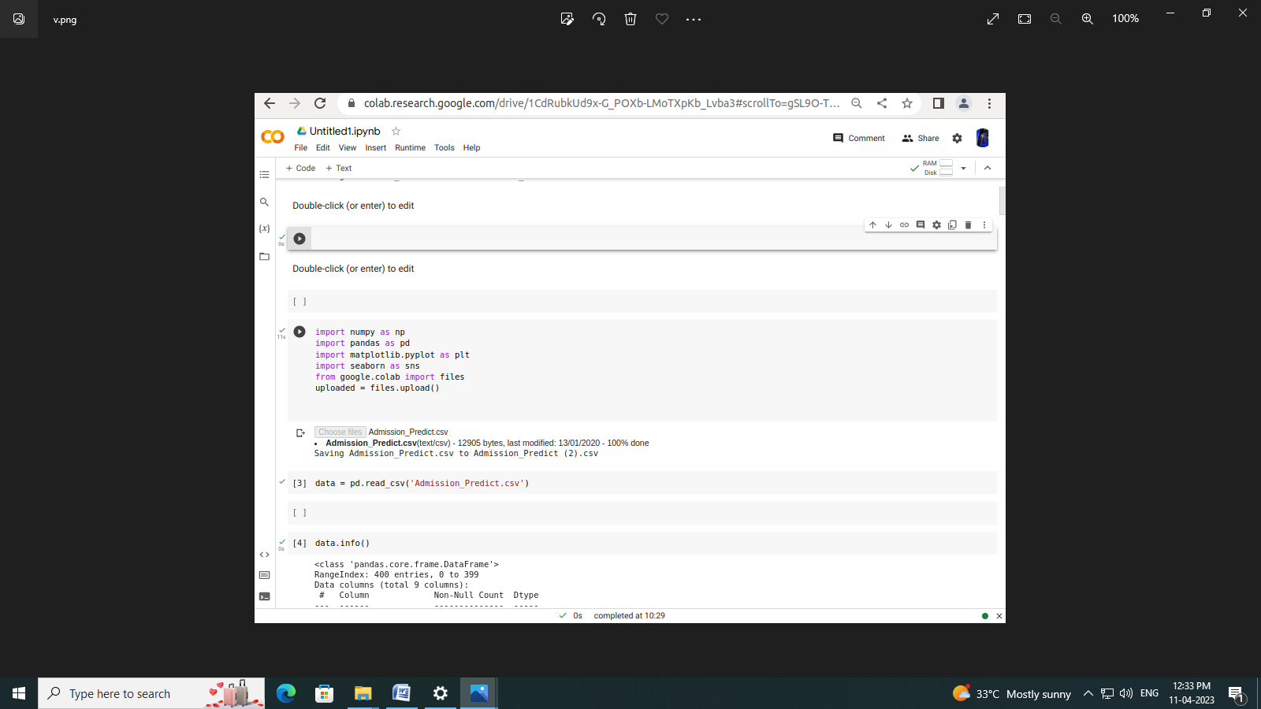

***Problem definition:***

Admission is permission [given](https://www.collinsdictionary.com/dictionary/english/given) to a person to enter a place, or permission given to a [country](https://www.collinsdictionary.com/dictionary/english/country) to enter an [organization](https://www.collinsdictionary.com/dictionary/english/organization). Admission is [also](https://www.collinsdictionary.com/dictionary/english/also) the act of entering a place.

*Students apply for admission to a particular college.*

*Criteria for admission to the EU prescribe that all member states must observe the rule of respect for minorities.*

Admissions to a place such as a [school](https://www.collinsdictionary.com/dictionary/english/school) or [university](https://www.collinsdictionary.com/dictionary/english/university) are the people who are [allowed](https://www.collinsdictionary.com/dictionary/english/allow) to enter or [join](https://www.collinsdictionary.com/dictionary/english/join) it.

*Each school sets its own admissions policy.*

Admissions to a place such as a [school](https://www.collinsdictionary.com/dictionary/english/school) or [university](https://www.collinsdictionary.com/dictionary/english/university) are the people who are [allowed](https://www.collinsdictionary.com/dictionary/english/allow) to enter or [join](https://www.collinsdictionary.com/dictionary/english/join) it.

*Each school sets its own admissions policy.*

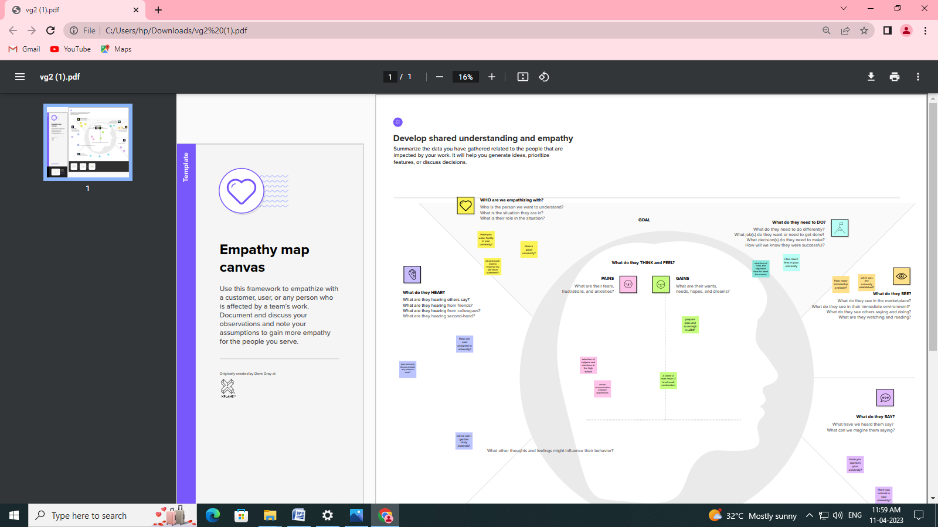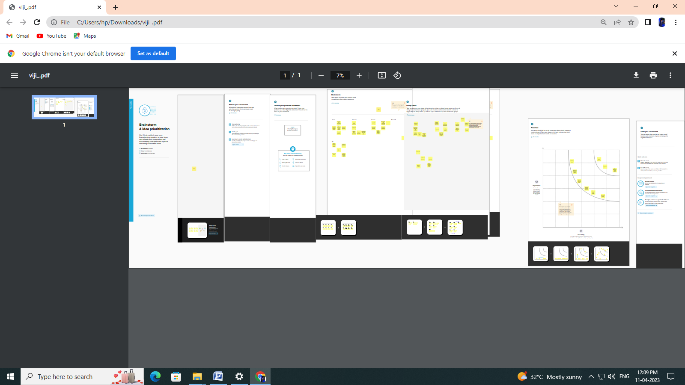

***Adavantage & Disadvantage:***

**Advantages of Online Admission**

Applicants’ Convenience – One of the greatest advantages of the online application system is that applicants can choose to submit their applications at their convenience.

All that is required is access to a computer and internet connectivity.

This is a great advantage to candidates in rural areas and candidates withdisabilitiesLogistics – No more running out of paper application forms, picking the right colour ink pens, illegible prints and wondering if the application has been received at all. The online application process offers university applicants a uniform platform for filling in their applications and also provides prompts on which fields are mandatory. The acknowledgement is almost immediate and the system user-friendly. This is a great advantage to candidates in rural areas and candidates with disabilities.

Advantage to Universities – Universities and educational institutions are also at a major advantage when it comes to an online admission process. Quick access to processing applications and employing additional manpower during admissions are slashed with the records and databases, efficient systems for filtering out candidates and processing of applications is possible through the online application process. The costs of implementation of an online application system.

Increases Accuracy and Efficiency – Those who have seen university officials accepting thousands of paper applications each day at office counters understand that high fatigue and monotony involved in the paperwork is a catalyst for errors. Each error could cost students their academic career and educational prospects. The online admission system is highly reliable and efficient and eliminates chances of such errors.

Demolishing Geography – Another great advantage of the online admission system is that it makes it possible for candidates from across the country and even abroadto apply to Indian universities without any hassles. It eliminates the inconveniencescaused by ailments and exigencies, providing deserving candidates a convenience that has never before been available.

Disadvantages of Online Admission

Computer Literacy and Internet Access – In India, though Internet penetration is rather high, Internet connectivity and speed issues are major impediments to bring any real advantage to university applicants. Most rural areas experience high blackouts and electricity issues. This means, once again candidates in urban districts and areas are placed at a significant advantage.

Low Computer Literacy – Another major concern is the low rate of computerliteracy in India. Current estimates say that only about 6.5 percent Indians are computer savvy. A sudden shift to the online admission process is likely to cause confusion and despondency among a great many applicants.

Security Concerns – In a country like India where security fails of online systems have become increasingly common over the years, online applications make it easier for systems to be breached and for applications or scores to be manipulated. The fear that hackers may target universities and educational institutions is a grave one. Unintentional system failures or server crashes may disrupt the entire admission process of universities and educational institutions. Another important concern is the confidentiality of student information and associated security risksinvolved in online application processing.

Authenticity – In most manual admission processes, the eligibility of candidates is proved by verification of originals at the time of accepting applications, ensuring that only genuine candidates apply. Online applications make it easier for fraudsters to manipulate the application process and eligibility requirements.

Infrastructural Requirements – Building a robust and secure online admission process is a task that requires financial and infrastructural resources. Many universities and educational institutions may not have the necessary resources and all these costs will ultimately be borne by the students. In a country where higher education is a luxury few can afford, increased costs may be a deterrent for education.

**Application:**

The education sector has undergone an enormous transformation in recent years, and that process is continuing to this day. Technology has made its way to the education sector and has revolutionized it, to the benefit of everyone.

Technology has made education dynamic and more accessible to society. It has also ushered in the much-needed reforms, which were the need of the time.  In a country like India, where its student population, at approximately three hundred and fifteen million, is larger than the world’s third most populous country, it essential that technology is incorporated with the education sector.

Technology helps bridge the gap between educational institutes and their students. It brings students and institutes closer, makes them more accessible and approachable to students.

To pursue higher education students often travel and migrate to cities far off, sometimes even migrating to different countries for better educational opportunities. In this case, online admission systems are a boon to students and educational institutes alike.

Students can seek relevant information about infrastructure, faculty, departments and so on via these online admission systems. But more importantly, students can fill these online admission forms for college and school admission forms from the comfort of their homes and without any hassle.

Online Admission Forms bridge the gap of the geographical barrier between students and educational institutions.

Now students don’t have to travel to fill out offline admission and registration forms at the institutions. This is a very comfortable and hassle-free process, benefiting students and educational institutions alike.

***Conclision:***

Your essay isone of the most essential parts of your college application. It's your chance to tell your story, using your unique voice to showcase your personality, achievements, and goals. And arguably, the ending of your essay is the most important part of it all. It's your last chance to make an impact and leave a lasting impression on the reader.

In this article, we’ll look at some do's and don’ts for ending your essay and giveyou five simple but effective techniques you can use to wrap things up. All right, enough chatter. On to the good stuff.Finding a conclusion for your college essay is one of the most challenging parts of writing it.

Once you have written the introduction and the body paragraphs of the essay, you might feel like you’ve said everything you intended to say. You might wonder what else is left.

There is risk in not concluding your essay well.

Your conclusion is likely the last thing an admissions officer is going to read.

It’s your final handshake with the reader.

It’s your exit through the door. The impression you leave in the final sentences of your essay will remain with your reader.

A great conclusion can be more powerful than anything featured on your transcript because it can set you apart from everyone else.

Here are tips for what to avoid, and what to do, in order to write the best conclusion for your college essay.

***Future scope:***

Chemistry1. Website and online portal for admission should be prepared well in advance and

ready portal should be demonstrated to the Admission Committee of the college

before final selection of the service provider. After the section of the service provider

selected party must present a trial run to the Admission Committee before the

commencement of receiving online applications.

2. An applicant should be able to fill up the form directly without any login. But a user

id and pa

The information technology industry is growing at a very fast pace. Every sector is adopting new and superior technologies to carry out tiresome tasks to optimise efficiency. The high demand for IT professionals in today’s world has made courses offered in this field really popular among masses. Bachelor of Science in Information Technology is one such course that equips students with knowledge of storage processing, securing, and maintaining databases and exposure to information processing. But before you sign up for the course, it is essential to know about the different career pathways you can explore. Here is an insightful blog on focusing on the BSc IT scope

***Appendix:***

*For admission to undergraduate courses in Universities/ Institutes in India require the applicants to have*

*completed at least 12 years of schooling (equivalent to10+2 system of Indian Education). Applicant*

*should have completed successfully 11thand / or 12th, as applicable in the respective boards.*

*The following foreign examination have been recognized by Association of Indian Universities (AIU) as*

*equivalent to +2 stage qualification of an Indian Board giving access to the Bachelor Degree programme*

*at Indian Universities. In case applicants qualification is not listed, they need to apply to AIU for an*

*equivalence certificate. (For details Visit Association of Indian Universities website*

*1. 12 years Baccalaureate Certificate of Chad, Gabon, France and Tunisia.*

*2. International Baccalaureate Diploma awarded by International Baccalaureate Organization*

*Geneva, Switzerland.*

*3. 12 years General Secondary Education Certificate of the Ministry of Education Bahrain, Egypt,*

*Jordan, Kuwait, Oman, Saudi Arabia, United Arab Emirates and other Gulf countries.*

*4. GCE/IGCSE/GCSE examinations of the approved British Examination Bodies, with Minimum 5*

*(Five) subjects in A, B, C Grades including English at ORDINARY (‘O’) Level and 2/3 subjects at*

*ADVANCED LEVEL has been equated with +2 stage qualification. Candidates intending to join*

*Professional courses are required to have passed the subjects of Physics*

*Biology/Mathematics in ADVANCED LEVEL & English at AS LEVEL.*

*5. 12 Year High School Diploma from accredited Schools of USA.*

*6. Intermediate/Senior Secondary/Higher Secondary examinations of the approved Boards in*

Pakistan,Bangladesh, Bhutan and Nepal.

7. 12 year Secondary Stage qualification of National Examinations Education,Ethiopia, Sudan.

8. 12-year Secondary Stage examination conducted by various Provinces in *Canada and Australia.

9. and Advanced” level examinati** GCE “Ordinary on of the Department of Education,

Government of Sri Lanka, Singapore, Hong Kong & Mauritius.

10. 12 year STPM examination of Malaysia.

11. 12 year Secondary Stage qualification of Indonesia, Japan, Korea, Republic of Vietnam and

Yemen Arab Republic

12. “Abitur” examination of Germany.

13. *** 12 year High School Diploma awarded by the accredited American Schools/International

Schools in other countries following American System of Education.

14. Pre University Certificate Examination of the Ministry of Education, Iran.

15. 12 year Secondary School Certificate Examination of the Ministry of Education, Islamic Republic

of Afghanistan.

16. 12 Year Secondary School Certificate Examination of the Ministry of Education, Islamic Republic

of Iraq.

17. 12 Year Senior School certificate Examination of West African Examinations Council (WACE) in A,

B, C Grades on a scale of 1-4 (A-1, B-2, B-3, C-4) conducted in the countries of Nigeria etc.

18. EXAMEN D’ETAT of the Ministry of Primary, Secondary & Professional Education in the

Democratic Republic of Congo.

19. 12 year Kenya Certificate of Secondary Education Examination with more than 5 (Five) subjects

in the Grades

‘A’ ‘B’ & ‘C’ of the Kenya National Examinations Council, Nairobi, Kenya.

20. Advanced Certificate of Secondary Education Examination with minimum 2 (Two) Principal

Passes & 2(Two) Subsidiary Passes of the National Examinations Council of Tanzania.

21. Uganda Advanced Certificate of Education Examination with minim (Two) Principal Passes

& 2(Two) Subsidiary Passes of the Uganda Examinations Board.

jects

in the Grades

‘A’ ‘B’ & ‘C’ of the Kenya National Examinations Council, Nairobi, Kenya.

20. Advanced Certificate of Secondary Education Examination with minimum 2 (Two) Principal

Passes & 2(Two) Subsidiary Passes of the National Examinations Council of Tanzania.

21. Uganda Advanced Certificate of Education Examination with minimum 2 (Two) Principal Passes

& 2(Two) Subsidiary Passes of the Uganda Examinations Board.